Mini Project Report

On

**THE RESULT SYSTEM**

By

Imadullah Shareef (1606-14-737-040)

Vrinda Lakhotia (1604-14-737-009)

Simran Kanthi (1604-14-737-017)

of

III/IV B.E. Sem-II (IT-A)

Under the Guidance of

Mr.Mohammed Afroze



DEPARTMENT OF INFORMATION TECHNOLOGY

**MUFFAKHAM JAH COLLEGE OF ENGINEERING AND TECHNOLOGY** (Affiliated to Osmania University )

Mount Pleasant, 8-2-249, Road No. 3, BanjaraHills, Hyderabad-34.

**MUFFAKHAM JAH COLLEGE OF ENGINEERING TECHNOLOGY**

(Affiliated to Osmania University )

Mount Pleasant, 8-2-249, Road No. 3, Banjara Hills, Hyderabad-34.



**DEPARTMENT OF INFORMATION TECHNOLOGY**

***CERTIFICATE***

This is to certify that the Mini Project work titled “THE RESULT SYSTEM” is a bonafide work prescribed by the Osmania University for B.E III/IV IT II/II Semester during the academic year 2016-2017 carried out by Vrinda Lakhotia(1604-14-737-009), Simran Kanthi(1604-14-737-017) and Imadullah Sharief(1606-14-737-040).

Faculty Incharge

**ACKNOWLEDGEMENT**

The austerity and satisfaction that one gets on completing a project cannot be fulfilled without mentioning the people who made it possible with gratitude.

We are grateful to the almighty God who helped us all the way throughout the project and also has molded us into what we are today. We express our sincere thanks to our parents who encouraged us always to achieve our goals.

We offer our sincere thanks to Muffakham Jah College of Engineering and Technology for allowing us to do our mini project in their esteemed institution.

We would like to thank **Mrs. Mousmi Ajay Chaurasia ma'am**, (**Head of the Department, Information Technology)** for her encouragement at various level of project.

We are Thankful to our guide **Mr.Mohammed Afroze** for his sustained inspiring Guidance and cooperation throughout the process of this project report.

We express our deep sense of gratitude and thanks to all the **Teaching** and **Non-Teaching Staff** of our college who stood with us and helped us to make it a successful venture.

**ABSTRACT**

Examination results have become easy to check with just an input of a roll no. or the name, but its analysis isn't the same. Complete analysis is the main requirement of an organization to know its precise result through which they know the areas to be worked on to improvise and be more effective. One at a time result is something which cannot compare the result of all the students and give the results we require, for this we have brought into picture the idea of THE RESULT SYSTEM. This is the most beneficial way anyone can get their doubts be it the top 10 toppers or the people who haven't attempted it.

**CONTENTS**

|  |  |  |
| --- | --- | --- |
| **Serial no.** | **Content** | **Page no.** |
| **1.** | **Introduction** |  |
| **2.** | **Literature Survey** |  |
| **3.** | **Software Requirement Specification** |  |
| **4.** | **System Design** |  |
| **5.** | **Implementation** |  |
| **6.** | **Screenshots** |  |
| **7.** | **Conclusion** |  |
| **8.** | **Bibliography** |  |

**INTRODUCTION**

The name of our website is THE RESULT SYSTEM. It consists of the following for all the sections and departments of M.J.C.E.T:

* Class-wise topper list
* Subject-wise topper list
* Individual Results

**LITERATURE SURVEY**

**Software Requirement Specification**

**-An active web browser and internet, to access the required webpage.**

**SOFTWARE:**

***HTML***

Hypertext Markup Language, commonly abbreviated as HTML, is the standard markup language used to create web pages.

Along with CSS, and JavaScript, HTML is a cornerstone technology used to create web pages, as well as to create user interfaces for mobile and web applications. Web browsers can read HTML files and render them into visible or audible web pages. HTML describes the structure of a website semantically and, before the advent of Cascading Style Sheets (CSS), included cues for the presentation or appearance of the document (web page), making it a markup language, rather than a programming language

***Database Management System:***

A database management system is a collection of interrelated data and a set of programs to access those data. The collection of data, usually referred to as database, contains information related to an enterprise. The primary goal of DBMS is to provide a way to store and retrieve database information that is both convenient and efficient. Database used is Oracle, Tool using SQL PLUS.

**System Design**

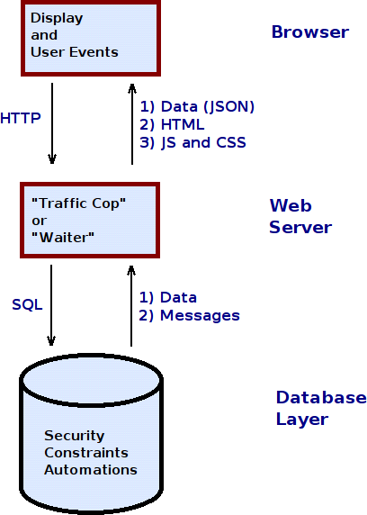

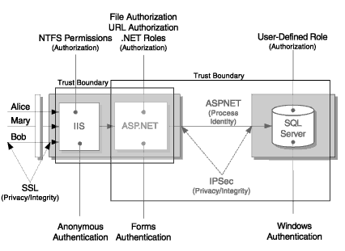

**Implementation ( Partial CODE):**

**INDEX PAGE:**

**<!DOCTYPE html>**

**<html lang="en-IN">**

**<head>**

**<title>Coffee Tech House</title>**

**<style>**

**p**

**{ text-align: center;**

**font-size:380%;**

**text-shadow: 4px 4px orange;**

**background-color:silver;**

**width:500px;**

**height:50px;**

**box-shadow:50px 50px 10px black }**

**p1**

**{ border: 6px solid black;**

**background-color:black;}**

**p6**

**{ text-color:yellow;**

**font-size:300%;}**

**p8**

**{ text-align:center;**

**text-color:blue;**

**font-size:400%;}**

**p10**

**{text-size:500%;}**

**p13**

**{text-size:400%;}**

**h1**

**{text-color:brown;}**

**body**

**{ background-image: url("kk.jpg");**

**background-blend-mode: dodge;}**

**</style>**

**</head>**

**<body>**

**<p><i><b>Coffee Tech House</i></b></p><p2>&nbsp&nbsp&nbsp&nbsp&nbsp&nbsp&nbsp&nbsp&nbsp&nbsp&nbsp&nbsp&nbsp&nbsp&nbsp&nbsp&nbsp&nbsp&nbsp&nbsp&nbsp&nbsp&nbsp&nbsp&nbsp&nbsp&nbsp&nbsp&nbsp&nbsp&nbsp&nbsp&nbsp&nbsp&nbsp&nbsp&nbsp&nbsp&nbsp&nbsp&nbsp&nbsp&nbsp&nbsp&nbsp&nbsp</p2>**

**<p1><img src="pp.png" width="150" height="150"></p1>**

**<p7>&nbsp&nbsp&nbsp&nbsp&nbsp&nbsp&nbsp&nbsp&nbsp&nbsp&nbsp&nbsp&nbsp&nbsp&nbsp&nbsp&nbsp&nbsp&nbsp&nbsp&nbsp&nbsp&nbsp&nbsp&nbsp&nbsp&nbsp&nbsp&nbsp&nbsp&nbsp&nbsp&nbsp&nbsp&nbsp&nbsp&nbsp&nbsp&nbsp&nbsp&nbsp&nbsp&nbsp<p6><b><a href="Home.html">Home</a></b></p6>&nbsp&nbsp&nbsp&nbsp&nbsp&nbsp&nbsp&nbsp&nbsp<p6><b><a href="About.html">About</a></b></p6>&nbsp&nbsp&nbsp&nbsp&nbsp&nbsp&nbsp<p6><b><a href="Menu.html">Menu</a></b></p6>&nbsp&nbsp&nbsp&nbsp&nbsp&nbsp&nbsp<p6><b><a href="Contact.html">Contact</a></b></p6></p7>**

**<p8 style="text-color:black;"><br><br>&nbsp&nbsp&nbsp&nbsp&nbsp&nbsp&nbsp&nbsp&nbsp&nbsp&nbsp&nbsp&nbsp&nbsp&nbsp&nbsp&nbsp&nbsp&nbsp&nbsp&nbsp&nbsp&nbsp&nbsp&nbsp&nbsp&nbsp&nbsp&nbsp&nbsp&nbsp&nbsp&nbsp&nbsp&nbsp&nbspVISION</p8>**

**</body>**

**</html>**

SCREENSHOTS

**INDEX PAGE:**

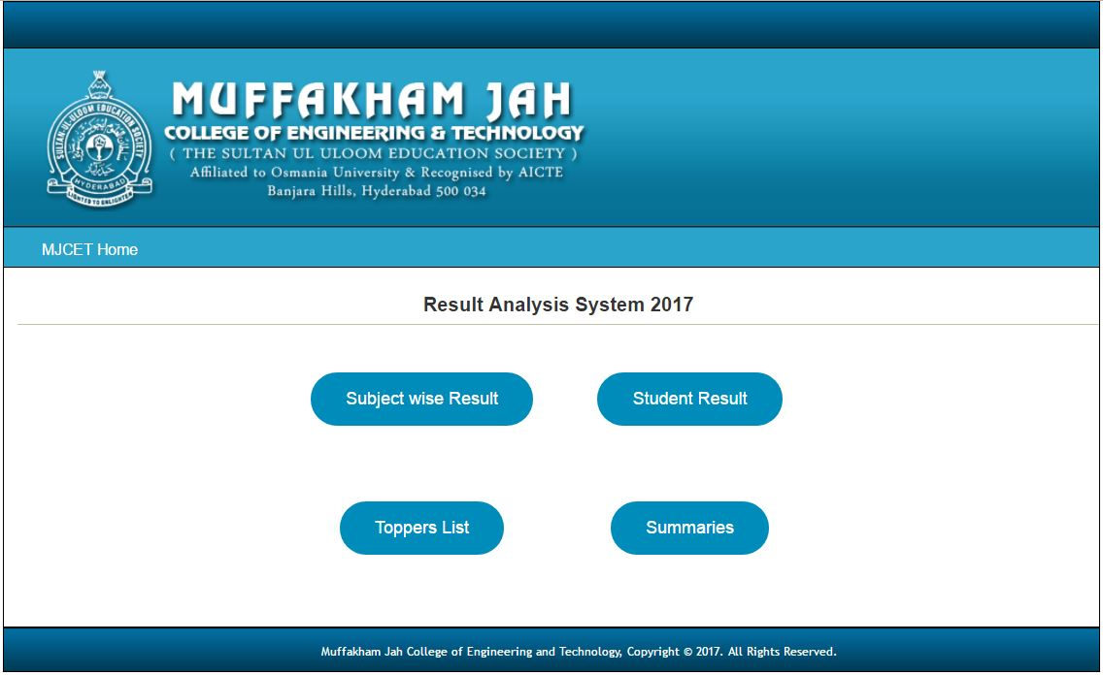

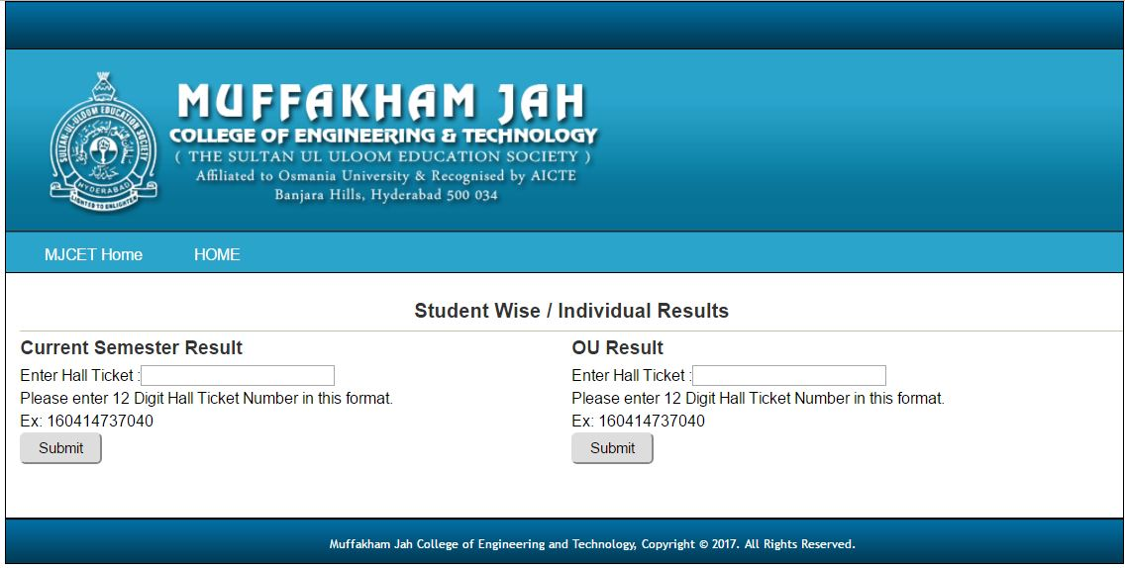

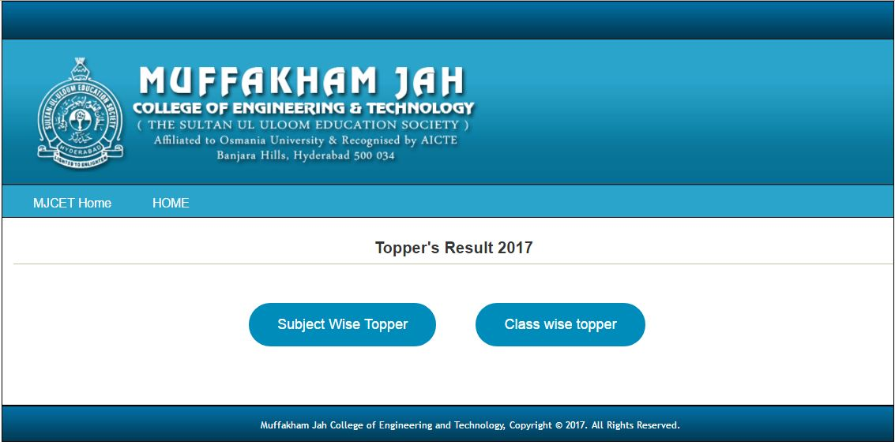

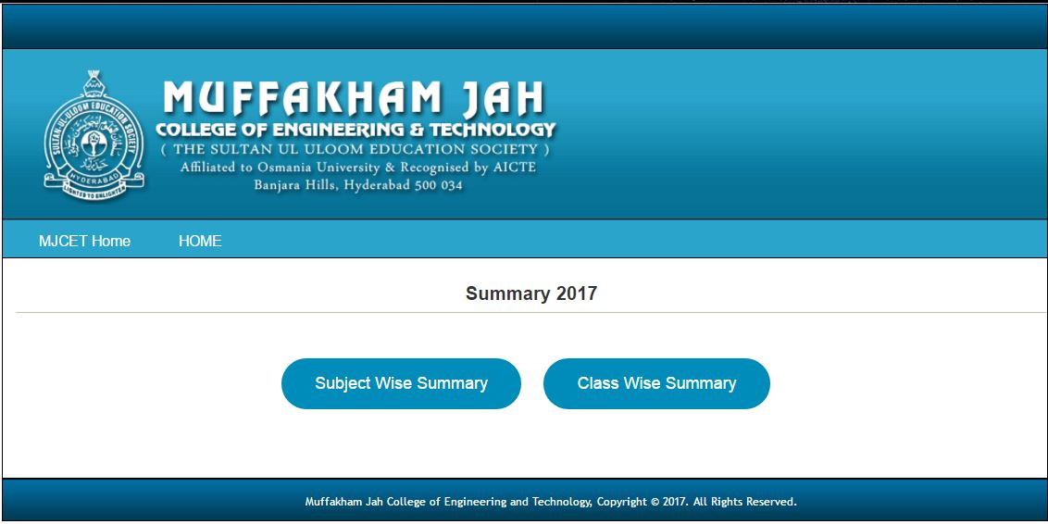

CONCLUSION

This project helped us a lot to know more about the software requirement and digital arenas and has boosted us to come out better with our idea and the implementation part. We learned how we can use the simple programming for showcasing of menu and has strengthened our basics in programming. We have learned how the restaurants and café work after our research and it has opened another world for us to be interested in. In future we are hopeful of opening a café and we are further hopeful of using this idea of ours and giving all the credits to the mini project for encouraging us and exploring us to so many combinations and options.

**FUTURE ENHANCEMENT**

We can make an application for our café and increase the list in the menu and the hardware. The project would also have server side programming required for the reviews given by the customers. We can open many branches for it around the world. We can sell coffee cups and coffee. We can even have the date and time added to our program. We can change the buttons to sending the voice of the customer himself/herself.

**BIBLIOGRAPHY**

[www.google.com](http://www.google.com/)

[www.wikipedia.com](http://www.wikipedia.com/)

[www.w3schools.org](http://www.w3schools.org/)

[www.tutorialspoint.com](http://www.tutorialspoint.com/)